**GOVERNMENT COLLEGE OF ENGINEERING , CHANDRAPUR**



PROJECT REPORT ON

**“IOT BASED ELECRICITY ENERGY METER USING ESP32 & BLYNK”**

*SUBMITTED BY*

Mr. RAMVEER B. YADAV (LAEDER)

Mr. ROHIT D. JIBHAKATE

Ms. FAHREEN A. SHEIKH

Ms. BHAVANA R. NISHAD

***GUIDED BY***

**M. P. DONGRE**

LECTURER,

DEPARTMENT OF ELECTRONICS & TELECOMMUNICATION

**DEPARTMENT OF ELECTRONICS & TELECOMMUNICATION ENGINEERING**

GOVERNMENT COLLEGE OF ENGINEERING, CHANDRAPUR

Ballarsha Bypass Road, Babupeth, Chandrapur 442401, Maharashtra

**2021-22**

*CERTIFICATE*

This is to certify that, this is the bonafide record of project work on, “**IOT BASED SMART ENERGY METER USING BLYNK**” of Mr. RAMVEER B. YADAV, Mr. ROHIT D. JIBHAKATE, Ms. FAHREEN A. SHEIKH, Ms. BHAVNA R. NISHAD, Electronics & Telecommunication Engineering, VIIIth Semester, Submitted in a satisfactory manner in the partial fulfillment of the requirement for the Diploma in Electronics & Telecommunication Engineering prescribed by “Gondwana university Gadchiroli”, during the academic year 2021-22.

H. O. D.

Mr. M. P. Dongre

GUIDE

Lecturer Electronics &

Telecommunication

Engineering

Dr. R. R. WAKODKAR

Electronics &

Telecommunication

Place : Chandrapur

Date:

**ACKNOWLEGMENT**

“We have taken efforts in this project. However, it would not have been possible without the kind support and help of many individuals. We would like to extend our sincere thanks to all of them.

We are highly indebted to Mr. M. P. DONGRE, Lecturer Electronics & Telecommunication Engineering their guidance and constant supervision as well as for providing necessary information regarding the project & also for their support in completing the project.

We would like to express our gratitude towards our parents for their kind co-operation and encouragement which help us in completion of this project.

We would like to take this opportunity to thank Dr. M. P. DONGRE, Head of department, Electronics & Telecommunication Engineering for his support & encouragement.

Our thanks and appreciation also go to our colleague in developing the project and people who have willingly helped us out with their abilities.’’

Mr. RAMVEER B. YADAV ()

Mr. ROHIT D. JIBHAKATE ()

Ms. FAHREEN A. SHEIKH (2019033700022885)

Ms. BHAVNA R. NISHAD (2019033700022879)

**CONTENTS**

**CHAPTER NAME PAGE NO.**

ABSTRACT

1. INTRODUCTION
   1. Objective
   2. Principle of operations
   3. System features
   4. Hardware requirements
2. DESCRIPTION OF PROJECT
   1. Block diagram of Transmitter & Receiver
   2. Description of Transmitter & Receiver
   3. Schematic Diagram of Transmitter
   4. Circuit Description of Transmitter
   5. Schematic Diagram of Receiver
   6. Circuit Description of Receiver
   7. PCB Layout of Transmitter
   8. PCB Layout of Receiver
3. DESIGNING AND PLANNING
   1. Layout planning
   2. Layout scale
   3. Layout procedure
   4. Layout sketch
   5. Artwork preparation
   6. Etching
   7. Etchants
   8. Rinsing
   9. Drilling
   10. Soldering

4. HARDWARE DESCRIPTION

4.1. IC AT89S52

4.1.1. Pin diagram

4.1.2. Description

4.1.3. Features

4.2. RF Transmitter Module

4.3. RF Receiver Module

4.4. PIR Sensor

4.5. 16X2 LCD

4.6. NE555 timer

5. BILL OF MATERIAL

6. SOFTWARE DESCRIPTION

6.1. Algorithm

6.2. Flowchart

6.3. Software used

7. ADVANTAGES

8. DISADVANTAGES

9. APPLICATIONS

10. FUTURE SCOPE

11. CONCLUSION

12. REFERENCES

13. DATA SHEET

**ABSTRACT**

In this project, we will learn how to make our own **IoT Based Electricity Energy Meter** using **ESP32** & monitor data on the **Blynk Application**. With the current technology, you need to go to the **meter reading** room and take down readings. Thus monitoring and keeping track records of your **electricity consumption** is a tedious task. To automate this, we can use the Internet of Things. The Internet of Things saves time and money by automating **remote data collection**. Smart **Energy Meter** has received quite a lot of acclaim across the globe in recent years. So, why not to build our own **IoT Based Electricity Energy Meter**?

We need to select the **current sensor** as well as the **voltage sensor** so that the current & voltage can be measured and thus we can know about the power consumption & total power consumed. The best current sensor available in the market is SCT-013. This is **SCT-013 Non-Invasive AC Current Sensor** Split Core Type Clamp Meter Sensor which can be used to measure AC current up to **100 amperes**. Similarly, the best voltage sensor is the AC Voltage Sensor Module ZMPT101B. The **ZMPT101B AC Voltage Sensor** is the best where we need to measure the accurate AC voltage with a voltage transformer.

Using the **SCT-013 Current Sensor & ZMPT101B Voltage Sensor**, we can measure the all required parameters needed for Electricity Energy Meter. We will interface the SCT-013 Current Sensor & ZMPT101B Voltage Sensor with **ESP32 Wifi Module** & Send the data to Blynk Application.

**CHAPTER 1**

**INTRODUCTION**

1. **INTRODUCTION**

IoT is also identified as an enabler for machine-tomachine,human-to-human and human-with-environment interactions.[1] The Internet of things (IoT) concept enables us to attach the traditional day-to-day devices with one another over the internet. The devices connected through the IoT concept can be analyzed remotely. The IoT concept provides the essential infrastructure and opportunities to make a connection between the physical world and computer-based systems [2]. The concept has been gaining importance with more and more wireless devices that are increasing rapidly within the market. Hardware devices are connected with one another over the web(Internet).

The ESP-8266 Wi-Fi module used in the system provides connectivity with the internet in the system. Nowadays the demand for electricity is increasing at a constant rate in the population and is being utilized for various purposes viz, agriculture, industries, household purposes, hospitals, etc. So, it is becoming more and more complicated to handle electricity maintenance and requirements. Therefore there’s an instantaneous requirement to save lots of the maximum amount of electricity as possible. As the demand from the newer generations of population for electricity is increasing so along with it the technology improvement is needed. The proposed system provides a 180 degree technical curve to the traditional energy meters using IoT technology. Also, there are other issues that we’ve dealt with like power theft which successively generate economic loss to the Country. Monitoring, Optimized power usage and reduction of power wastage are the main objectives that lie ahead of a far system[2].

* 1. Ojective
  2. Principle Of Operation
  3. System Features

**1.6. HARDWARE REQUIRED**

|  |
| --- |
| * ESP32 Board |
| * Voltage Sensor |
| * Current Sensor |
| * LCD Display |
| * Resistor |
| * Resistor |
| * Capacitor |
| * Connecting Wires |
| * Breadboard |
| * Blynk Application |



**CHAPTER 2**

**DESCRIPTION OF PROJECT**

IN THIS PROJECT, we will learn how to make our own **IoT Based Electricity Energy Meter** using **ESP32** & monitor data on the **Blynk Application**. With the current technology, you need to go to the **meter reading** room and take down readings. Thus monitoring and keeping track records of your **electricity consumption** is a tedious task. To automate this, we can use the Internet of Things. The Internet of Things saves time and money by automating **remote data collection**. Smart **Energy Meter** has received quite a lot of acclaim across the globe in recent years. So, why not to build our own **IoT Based Electricity Energy Meter**?

We need to select the **current sensor** as well as the **voltage sensor** so that the current & voltage can be measured and thus we can know about the power consumption & total power consumed. The best current sensor available in the market is SCT-013. This is **SCT-013 Non-Invasive AC Current Sensor** Split Core Type Clamp Meter Sensor which can be used to measure AC current up to **100 amperes**. Similarly, the best voltage sensor is the AC Voltage Sensor Module ZMPT101B. The **ZMPT101B AC Voltage Sensor** is the best where we need to measure the accurate AC voltage with a voltage transformer.

Using the **SCT-013 Current Sensor & ZMPT101B Voltage Sensor**, we can measure the all required parameters needed for Electricity Energy Meter. We will interface the SCT-013 Current Sensor & ZMPT101B Voltage Sensor with **ESP32 Wifi Module** & Send the data to Blynk Application.

the Internet of Things. The Internet of Things saves time and money by automating **remote data collection**. Smart **Energy Meter** has received quite a lot of acclaim across the globe in recent years. So, why not to build our own **IoT Based Electricity Energy Meter**?

The list of components required for making **IoT Based Electricity Energy Meter** are given below. Most of the components can be ordered online from Amazon.

| **S.N.** | **Components** | **Description** | **Quantity** |  |
| --- | --- | --- | --- | --- |
| 1 | ESP32 Board | ESP32 Development Board (ESP-WROOM-32) | 1 |
| 2 | Voltage Sensor | ZMPT101B AC Voltage Sensor Module | 1 |
| 3 | Current Sensor | SCT-013-030 Non-invasive AC Current Sensor | 1 |
| 4 | LCD Display | 16X2 I2C LCD Display | 1 |
| 5 | Resistor | 10K | 2 |
| 6 | Resistor | 100 ohm | 1 |
| 7 | Capacitor | 10uF | 1 |
| 8 | Connecting Wires | Jumper Wires | 10 |
| 9 | Breadboard | - | 1 |
| 10 | Blynk Application |  | 1 |

**CHAPTER 3**

**BLOCK DIAGRAM**

**BLOCK DIAGRAM :**

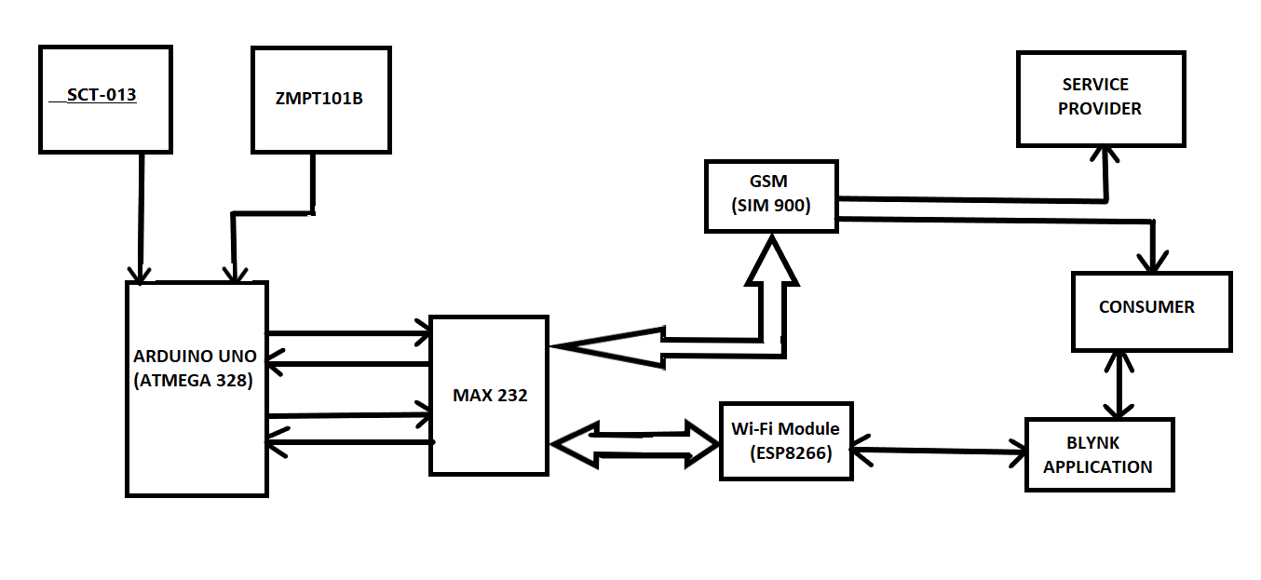

WORKING

* Current Sensor measures the current flowing through load.
* Voltage Sensor measures the voltage in the circuit.
* Aurdino reads the current and voltage values and sends it to Blynk application through ESP8266 Wi-Fi module.
  + - * The Blynk Application Dashboard will Continuously display the Voltage, Current, Power & total unit consumed in kWh.
      * The overall monthly bill with cost will be sent to customer as well as service provider in the form of text at first day of every month using GSM Module.
      * Threshold value can be set on Blynk application with the help of Wi-Fi, as per the consumer’s requirement. When the consumers reading will be near about to the set threshold value it will send a notification value to the consumer.

**CIRCUIT DIAGRAM**

## 

## Now let us see the circuit diagram of IoT Based Electricity Energy Meter using ESP32. The circuit has been designed using Fritzing software.The connection diagram is simple. Both the Sensor, i.e. SCT-013 Current Sensor & ZMPT101B Voltage Sensor VCC is connected to Vin of ESP32 which is a 5V Supply. The GND pin of both the modules is connected to the GND of ESP32. The output analog pin of the ZMPT101B Voltage Sensor is connected to GPIO35 of ESP32. Similarly, the output analog pin of SCT-013 Current Sensor is connected to GPIO34 of ESP32. You need a two resistor of 10K & a single resistor of 100 ohms connected along with a 10uF Capacitor. Apart from the circuit part, the AC wires where the current and voltage needs to measured are connected to the input AC Terminal of Voltage Sensor. Similarly, the current sensor clip doesn’t have any connection and a single live wire or neutral wire is inserted inside the clip part as shown in the above circuit.

## COMPONENT DESCRIPTION

## ****SCT-013 Current Sensor****

[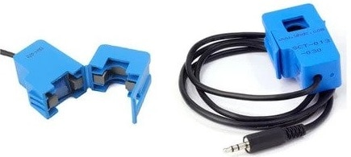](https://how2electronics.com/wp-content/uploads/2020/12/SCT-013-Current-Sensor.jpg)

The [**SCT-013**](https://www.mcielectronics.cl/website_MCI/static/documents/Datasheet_SCT013.pdf) is a Non-invasive AC Current Sensor Split Core Type Clamp Meter Sensor that can be used to measure **AC current** up to 100 amperes. Current transformers (CTs) are sensors are for measuring alternating current. They are particularly useful for measuring whole building electricity consumption. The SCT-013 current sensors can be clipped straight either to the **live** or **neutral wire** without having to do any high voltage electrical work.

Like any other transformer, a **current transformer** has a primary winding, a magnetic core, and a secondary winding. The secondary winding comprises many turns of fine wire housed within the casing of the transformer.

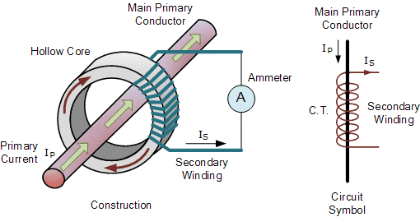

Like any other transformer, a current transformer has a primary winding, a magnetic core, and a secondary winding. The secondary winding comprises many turns of fine wire housed within the casing of the transformer

**ZMPT101B AC Single Phase Voltage Sensor**

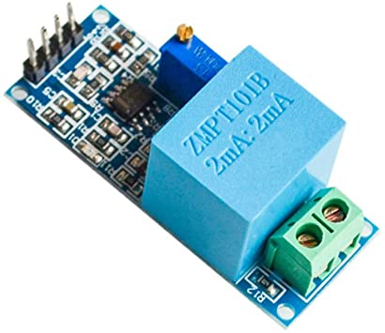

The ZMPT101B AC Single Phase voltage sensor module is based on a high precision ZMPT101B voltage Transformer used to measure the accurate AC voltage with a voltage transformer. This is an ideal choice to measure the AC voltage using Arduino or ESP32. The Modules can measure voltage within 250V AC voltage & the corresponding analog output can be adjusted. The module is simple to use and comes with a multi-turn trim potentiometer for adjusting and calibrating the ADC output.

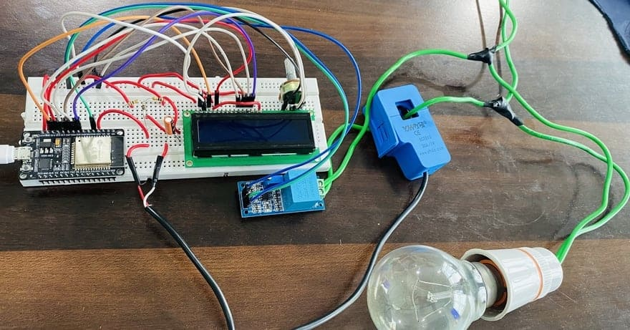

The 16x2 LCD used in this project is optional. There is no need to connect the LCD as we will be monitoring the ESP32/SCT-013 ZMPT101B/ Energy Meter Data on Blynk Application. In case you want to connect the LCD, you need so many connections. Connect the pin numbers 4, 6, 11, 12, 13, 14 of LCD to ESP32 D13, D12, D14, D27, D26, D25 pins. Also connect the LCD 1, 5, 16 Pin to GND & 2, 15 Pin to 5V VCC. Use a 10K Potentiometer at Pin 3 of LCD to adjust the LCD Contrast.

If you don’t want to assemble the circuit on breadboard and you want PCB for the project, then here is the PCB for you. The PCB Board for the IoT Energy Meter is designed using EasyEDA online Circuit Schematics & PCB designing tool. The front side and back side of the PCB is given below.

**Required Library Installation**

1. EmonLib Library The Emonlib Library is used for Electricity Energy Meter. EmonLib is a Continuous Monitoring of Electricity Energy repeats, every 5 or 10s, a sequence of voltage and current measurements. EemonLib continuously measures in the background the voltage and all the current input channels, calculates a true average quantity for each and then informs the sketch that the measurements are available and should be read and processed. Download EmonLib Library

2. Blynk Library Blynk is the most popular Internet of Things platform for connecting any hardware to the cloud, designing apps to control them, and managing your deployed products at scale. With Blynk Library you can connect over 400 hardware models including Arduino, ESP8266 & ESP32 to the Blynk Cloud.

**ESP32**

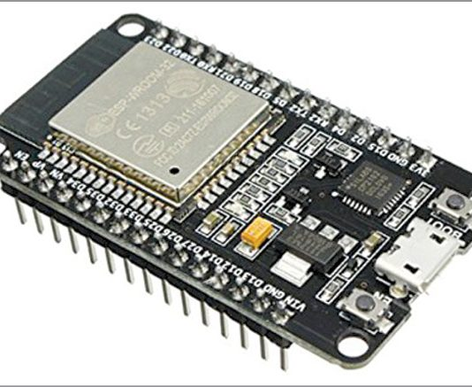

Many in the maker community and beyond have probably heard of [Arduino](https://all3dp.com/topic/arduino). This series of microcontroller boards is a popular choice in education, maker, and even commercial projects. It’s easy to see why: It has global community support and plenty of add-ons. There are many ways to use an Arduino, including [beginner-friendly projects](https://all3dp.com/2/easy-simple-arduino-projects/) as well as [3D printed creations](https://all3dp.com/2/best-3d-printed-arduino-project/).

This article is a getting started guide for the ESP32 development board. If you’re familiar with the [ESP8266](https://randomnerdtutorials.com/tutorials-esp8266/), the ESP32 is its sucessor. The ESP32 is loaded with lots of new features. The most relevant: it combines WiFi and Bluetooth wireless capabilities and it’s dual core.

**CHAPTER 4**

**SOFTWARE PROGRAMMING**

**ADVANTAGES**

* **Cost is less as compared to the system.**
* **Less labour cost.**
* **Remote access of metre reading and real time bill monitoring.**
* **Makes every customer a self interested guardian of power(energy) supply.**
* **Power utilisation is accurately calculated.**

**This threshold value notification will increase the awareness amongst the consumer about the**

**APPLICATIONS**

* **Makes it easier for MSEB to generate bill with less manpower.**
* **Enables users to track their energy consumption daily which helps them save energy.**
* **It has wide range of application in residential and commercial building in a public energy supply system monitoring.**

**It has application in public power sources.**

**FUTURE SCOPE**

* **The project mainly aims at providing overall infrastructure of the energy metre used for smart city concept using new technologies.**
* **The main improvement for the future is going to make energy metre readings tampering identification techniques and corrections easy.**

**This will help in reducing the wastage of energy and bringing awareness among all. Even it will deduct the manual intervention**

**CONCLUSION**

* **IoT based energy meter has proven to be the best way of billing.**
* **It will reduce the wastage of energy.**
* **It will deduct manual intervention.**
* **It is low cost and can be remotely controlled.**

**REFFERENCE**

* **Himshekhar das, L.C.Saikia, “GSM enabled smart energy meter and automation of home appliances”, PP-978-14678-6503-1, 2015 IEEE.**
* [**Https://en.Wikipedia.Org/wiki/smart_meter**](https://en.wikipedia.org/wiki/smart_meter)
* [**Https://irejournals.Com/formatedpaper/1700763.Pdf**](https://irejournals.com/formatedpaper/1700763.Pdf)
* [**Https://youtu.Be/0o6jpj9twpw**](https://youtu.be/0o6jpj9twpw)
* [**Https://youtu.Be/dn3ggaps0ma**](https://youtu.be/dN3GGaPs0MA)